Papa Pie’s Italian Restaurant

Wentworth Institute of Technology

Databases COMP2560

Prof. Nguyen Thai

September 26, 2021

Tyler Karpowicz and Richard Walters

**Papa Pie’s Italian Restaurant**

**Food and Services**

Our restaurant, Papa Pie’s Italian Restaurant, offers fine Italian dining. Some of the appetizers that we sell in our restaurant include meatballs, fresh mozzarella, Caesar salad, and roasted eggplant. Some of our entrees include chicken alfredo tortellini, margarita pizza, plain pizza, chicken cutlets, and fresh chicken marsala. Furthermore, we have a great selection of deserts such as fresh strawberry gelato, peach tart, and a classic tiramisu. Additionally, we serve drinks such as espresso, wine, champagne, and sparkling water. Lastly, our Kids menu features burgers, pasta, chicken tenders, mozzarella sticks, accompanied with a side of fries for each meal.

Papa Pie’s Italian Restaurant offers a wide variety of specialized features and services. Our restaurant comes equipped with both indoor as well as outdoor seating. Along with the topic of seating, we have two, four, and twelve seated tables, as well as booths that hold 4-6 people each. In our classic, Italian-style restaurant, we are equipped with multiple different servers in charge of taking care of customers' order requests. Our kitchen is also equipped with a variety of talented chefs, ready to cook some of the best Italian food. Lastly, our restaurant offers daily wine tasting equipped with a variety of different locally fermented wines.

**Business Statement**

Papa Pie’s Italian Restaurant will be a brand-new chain of Italian restaurants dedicated to providing only the finest Italian cuisine. It will have locations all over New England.

**Key Components of Business Operations**

Papa Pie’s Italian Restaurant requires many significant components to operate as a proper, successful business. As database engineers, we must keep track of and organize a variety of key business components. We must keep track of the products that each restaurant provides, facilities and equipment used in the business, and manage employee and company finances. To keep track of what products each restaurant provides, we must group up the categories of products, as well as organize the subcategories that they belong in. The major group of the products provided by each restaurant would be known as, Products Provided. This group will contain all the subgroups of different types of menu items offered at the restaurant. The subgroups of Products Provided would be the Entrees, Appetizers, Drinks, and Kids Menu Items. The Entrees subgroup would contain all the restaurant's signature entrees, chicken alfredo tortellini, margarita pizza, plain pizza, chicken cutlets, and fresh chicken marsala. Additionally, the Appetizers subgroup would contain all the restaurant's signature appetizers, meatballs, fresh mozzarella, Caesar salad, and roasted eggplant. The Drinks subgroup would contain all the restaurant's signature drinks, espresso, wine, champagne, and sparkling water. Lastly, the Kids Menu Items subgroup would contain all the restaurant's signature kids menu items, burgers, pasta, chicken tenders, mozzarella sticks, accompanied with a side of fries for each meal. The organization of the different products provided will allow for easier accessibility and readability of products at the restaurant.

Keeping track of facilities and equipment used in the business is essential for business efficiency and organization. To keep track of what facilities and equipment are used in the business, we must group up the categories of facilities and equipment, as well as organize the subcategories that they belong in. The major groups of the facilities and equipment used in the business would be known as, Equipment and Facilities. These groups will both contain all the subgroups of different types of equipment and facilities. The subgroups of Equipment would be categorized into, Kitchen Equipment and Dining Equipment. First, the subgroups of Kitchen Equipment would be, Cookware Appliances, and Storage. The Cookware subgroup would contain pots, pans, ladles, pizza pans, cheese graders, knives, and tasting spoons. The Appliances subgroup would contain stoves, fryers, pizza ovens, and a ticket printer. The Storages subgroup would contain shelves, a walk-in fridge, below the counter fridges, and a freezer. Next, the subgroups of Dining Equipment would be, Utensils and Server Equipment. The Utensils subgroup would contain the plates, forks, knives, napkins, and glasses used by the customers. The Server Equipment subgroup would contain pens, paper, uniform, as well as a register to put orders through. Finally, the subgroups of Facilities would be, Bathrooms, Dining Areas, and Storages. The subgroup of Dining Areas would contain additional subgroups, Indoor Dining and Outdoor Dining. The Indoor Dining as well as Outdoor Dining subgroups would both contain chairs, tables, menus, and booths. The subgroup of Bathrooms would contain sinks, toilet paper, mirrors, stalls, soap, and hand dryers. The grouping of the different facilities and equipment used in the business operation establishes ease of use and readability of the facilities and equipment at the restaurant.

Managing employee and company finances is essential in maintaining a proper restaurant. To keep track of company expenses and gains, we must create the categories of Expenses and Gains, as well as organize the subcategories that they belong in. First, the major group of Gains would contain daily earnings, weekly earnings, and average customer spending. Next, the major groups of Expenses would be known as Food Orders, Bills, and Employees. The group of Food Orders would contain the total cost and frequency of orders. The group of Bills would contain mortgage, electrical, water, heat, and AC. Finally, the subgroups of Employees would be Full Time, Part Time, Management, and Head Chef. These subgroups would all contain the hours and hourly wage for each subgroup respectfully. The management of employee and company finances through grouping creates an easy-to-understand format for keeping track of financial responsibility at the restaurant.

**Business Operation Rules and Management**

All foods will be made in house and ingredients will be sourced locally when available. There will be no discrepancies between menus of different locations. Papa Pie’s will be a sit down only restaurant but will provide takeout boxes for when people don't finish their meals. The restaurant will be walk-in only and will take payment through cash or cards.

**Operation Costs: Our Business vs the Industry**

Keeping track of and identifying business operation costs, allows Papa Pie’s to easily compare, as well as maintain the lead over similar businesses in the industry. To properly compare Papa Pie’s Italian Restaurant to businesses of similar stature, we must create a properly structured database to track the restaurant’s operating costs. To perform this task, we must keep track of store locations, how the company pays for inventory, the availability of ingredients, and the pay rates of employees in the business. Keeping track of store locations gives the business a well thought out visual of which restaurants are in which areas of the country. To keep track of store locations, we must create the category of Location, as well as organize the subcategories belonging to it. The category of Location would first have the subgroup of State containing the town and address of the restaurant, as well as the subgroup restaurant. The subgroup of State would contain the subgroup of Store. The subgroup of Store would then contain owner, rent, weekly profit, and the subgroup of Employees. The subgroup of Employees would then contain manager, head chef, cooks, servers, front-end, and bussers, as well as the cost of each employee respectively. The grouping of different store locations of the business allows for a greater understanding of the financial costs of each restaurant.

Determining company inventory expenses is essential for maintaining a profitable business. To create a detailed explanation of company expenses, we must create the category of Inventory Costs, as well as organize the subcategories of Inventory Costs that belong to it. The subgroups of Inventory Costs would be Food and Equipment. First, the subgroup of Food would contain costs of food orders, as well as extra food products required from a store due to a shortage of a certain ingredient. Furthermore, the subgroup of Equipment would contain costs of front-end, technology, kitchen, and dinning room equipment. The grouping of company inventory costs creates an easily computable cost of company inventory.

Determining the availability of ingredients is essential in establishing an ordered restaurant. To keep track of the availability of ingredients, we must create the category of Food Availability, as well as organize the subcategories that belong in it. First, the category of Food Availability would contain the major groups of Local Providers and Corporate Providers. The subgroup of Local Providers would contain the subgroups of Dairy Farmers, Crop Farmers, and Butchers. The subgroup of Dairy Farmers would contain availability details of milk and cheese. The subgroup of Crop Farmers would contain availability details of the seasonal crops such as fall crops, winter crops, spring crops, and summer crops. The subgroup of Butchers would contain the availability details of Chicken, Steak, and Pork. Moreover, the major group of Corporate Providers would contain the availability details of starch, flour, different types of drinks, sauces, herbs, and spices. Determining the availability time frames of food products for the restaurant allows for a stable circulation of menu items throughout the seasons.

Managing the various pay rates of employees in the business can be a headache. In order to reduce confusion and promote economic stability of the restaurant it is essential that our database models the major group of Worker Salaries. To keep track of Worker Salaries, we must create the subgroups of Low-Level Workers and High-Level Workers. The subgroup of Low-Level Workers targets workers with high school diplomas as a work requirement, and contains the pay rates of Server, Cook, Front-End, and Busser. The subgroup of High-Level Workers targets workers with college education or culinary school experience. Workers that fall into the details of High-Level Workers are the Head-Chef and the Manager. Keeping track of the pay rates of multiple different skill levels of employees through a database, provides an effortless report on who is making how much money in Papa Pie’s Italian Restaurant.

**Daily Operational Tracking Data**

The busiest nights are Fridays and the weekend with an up to 30% increase in sales versus other nights. The restaurant will be open year-round and will be closed for most major holidays.

**Operational Information: Putting Our Business Above the Rest**

Papa Pie’s Italian Restaurant is a restaurant that needs to prove as well as promote that they are truly above the rest when it comes to the dining experience. Providing relevant business operation information though a database enables managers to easily understand what needs to be changed and done in the restaurant to improve business competitiveness. To organize this relevant business information, we must create a database that focuses on Papa Pie’s vs the competition. Major groups of this database include hours open, peak hours, specials offered, prices, as well as unique features of Papa Pie’s compared to the competition.

Determining hours open and peak hours in Papa Pie’s as well as how it lines up against the competition is essential in maintaining a top spot for the restaurant above the rest. The major groups of Hours Open, Competition Hours Open, Peak Hours, Competition Hours can allow for a more organized comparison of how the restaurant lines up against the rest. The major groups of Hours Open and Competition Hours Open, both have the subgroups of Weekdays and Weekends, as well as the details of day open, time open, and time closed respectively. The major groups of Peak Hours and Competition Peak Hours, both have the subgroups of Weekdays and Weekends, as well as the details of day, start time of peak hours, and end time of peak hours respectively. The availability to see how Papa Pie’s peak hours as well as hours of operation stack up against the competition, enable the restaurant to easily figure out how much better, worse, or similar they’re doing compared to the competition, and determine whether there need to be changes towards improvements.

Keeping track of specials, deals, and prices of Papa Pie’s Restaurant compared to the competition allows the creation of a competitive edge against the competition. The major groups of Prices, and Competition Prices provides further insight as to how Papa Pie’s compares to the competition financially. The major groups of Prices and Competition Prices both contain menu item prices of Entrees, Appetizers, Deserts, Drinks, and Kid Menu item prices, as well as subgroups of Specials and Deals respectively. The subgroups of Specials and Competition Specials both contain details on the name of the special, frequency of the special, and price of the special respectively. The subgroup of Deals and Competition Deals provide details on the type of deal, price reduction of the deal, date, and frequency of the deal (daily, weekly, or monthly) respectively. The ability to easily see just how Papa Pie’s prices, deals, and specials compare against the competition furthers business productivity and profit.

Setting the restaurant appart from the competition, and providing a unique, clean, inviting atmosphere that separates Papa Pie’s Italian Restaurant from the competition is essential in maintaining head room against the competition. To keep track of the dining atmosphere as well as the competition’s dining atmosphere, we must create the categories of Dining Atmosphere and Competition Dining Atmosphere. Dining Atmosphere and Competition Dining Atmosphere are both made up of the subcategories Walls, Seating, Decorations, Windows, Lighting and Restaurant Smell. First, the subgroup of Walls would contain details on wallpaper type and wall painting color respectively. Next, the subgroup of Seating would contain the details of types of chairs, booths, and tables, and number of chairs, booths, and tables respectively. The subgroup of Decorations would contain table decorations, wall decorations, as well as plants respectively. The subgroup of Windows would contain the details along with the number of windows, types of windows, number of windows on a given wall, as well as window placement respectively. The subgroup of Lighting would hold the values of types of lights, how many lights, and location of lights respectively. Finally, the subgroup of Restaurant Smell would represent what type of smell is in the restaurant, and how powerful the smell is (on a scale of 1-10) respectively. The grouping of the restaurant atmosphere at Papa Pie’s compared to the competition, enables Papa Pies to stand out amongst the competition, and improve upon its unique style of restaurant.

Acknowledging the disadvantages of Papa Pie’s and the disadvantages of the competition enable the restaurant to determine what’s wrong with the business and how they can rise above the competition. To keep an accurate note of disadvantages of Papa Pie’s and the competition, as well as how to improve competition, we must create the major groups of Disadvantages, Competition Disadvantages, and Improving Competition. The major groups of Disadvantages and Competition disadvantages both contain details of financial gains, expenses, parking costs, number of menu items, types of menu items, number of customers on a daily/weekly basis, as well as location respectively. The major group of Improving Competition contains subgroups of Special Events and Restaurant Promotion. The subgroup of Special Events contains the details of date of special event, unique special dish, and type of eating competition. The subgroup of Restaurant Promotion contains details on date of promotion, invitational guest (famous person), and local marking (providing samples of food in the town). The ability to easily understand just the disadvantages of Papa Pie’s Italian Restaurant, how they compare to the competition, as well as ways to improve competition though a database creates promotes the status, reputation, as well as establishes desirability of the restaurant amongst customers though easily identifiable necessary improvements.

**Data Modeling**

**Entity List**

Papa Pie’s Italian Restaurant LLC

LLCID

Date Founded

Number of Locations

Papa Pie’s Location

Location ID

Address

Hours Open

Weekly Gain

Lease

Employee

Employee ID

Home Address

Phone Number

Employment Date

[Tenure]

Position

Employee Type

Full-Time Employee (Subtype Discriminator)

Hourly Pay Rate

Hours Worked

Part-Time Employee (Subtype Discriminator)

Hourly Pay Rate

Hours Worked

{Restrictions}

{Availability}

Salary Employee (Subtype Discriminator)

Salary

Hours Worked

Facilities

Facility ID

Facility Type

Dining Area

Amount of Tables

Amount of Chairs

Outside?

Outdoor Dining (Subtype Discriminator)

Amount of Umbrellas

Kitchen

{Appliances (type, amount)}

Competition Metrics

Competition Metrics ID

Extra Income Amount (Promotional, Renovation)

Extra Cost Amount (Promotional, Renovation)

Equipment

Equipment ID

Item type

Amount

Location

Cost

Supplier

Supplier ID

Address

{Contact Info}

Ingredient

Ingredient ID

Stock

Cost

Seasonal?

Seasonal Ingredient

Dates Available (Start Date, End Date)

Menu Item

Menu Item ID

Item Type

Est Prep Time

Cost

Seasonal?

Seasonal Item

Dates Available (Start Date, End Date)

**Entity Relationship List**

1. Papa Pie’s Italian Restaurant LLC must have at least one location
2. Papa Pie’s Location must belong to only one LLC.
3. Papa Pie’s Location must have at least one supplier.
4. A supplier must supply one Papa Pie’s location.
5. A supplier must supply at least one ingredient.
6. An ingredient must be supplied by one supplier.
7. Papa Pie’s Location must have at least one ingredient.
8. An ingredient belongs to one Papa Pie’s location.
9. An ingredient must be contained in at least one menu item.
10. A menu item contains at least one ingredient.
11. Whether or not an ingredient is seasonal or not, must be recorded.
12. Papa Pie’s Location must have at least one menu item.
13. A menu item belongs to one Papa Pie’s location.
14. Whether or not a menu item is seasonal or not, must be recorded.
15. Papa Pie’s Location must have at least one employee.
16. An employee belongs to one Papa Pie’s location.
17. Whether or not an employee is full time, part time, or a salary employee, must be recorded.
18. Papa Pie’s Location must have at least one facility.
19. A facility belongs to one Papa Pie’s location.
20. Whether or not a facility is a dining area, outside dining area, or a kitchen, must be recorded.
21. Papa Pie’s Location may have one or more competition metric(s).
22. The competition metrics must be associated with one Papa Pie’s location.
23. A facility belongs to one Papa Pie’s location.
24. Papa Pie’s Location must have at least one equipment item.
25. An equipment item belongs to one Papa Pie’s location.
26. An equipment item must be supplied by one supplier.
27. A supplier must supply at least one equipment item.

**Papa Pie’s ERD**

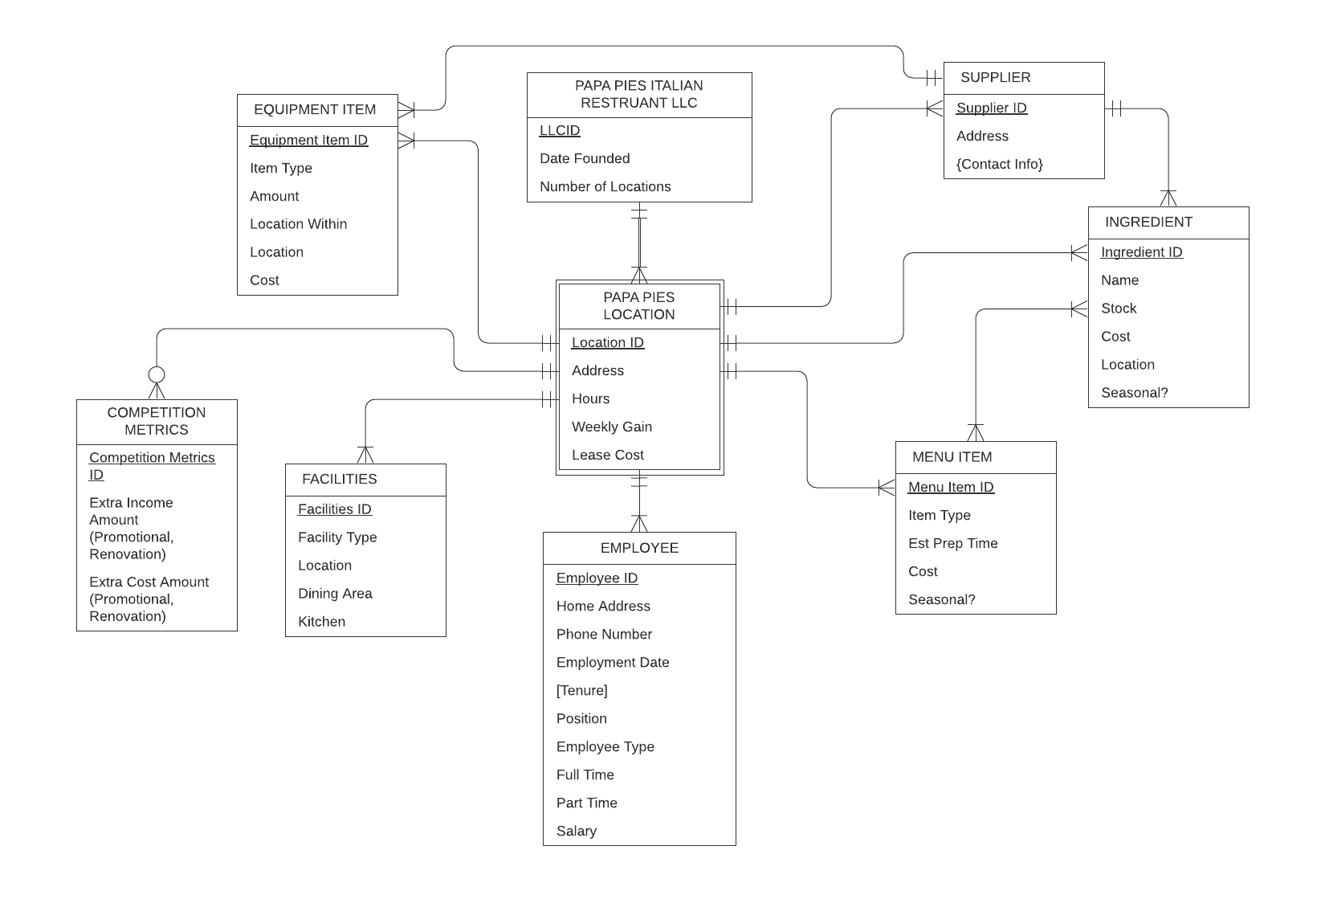

**Papa Pie’s EERD**

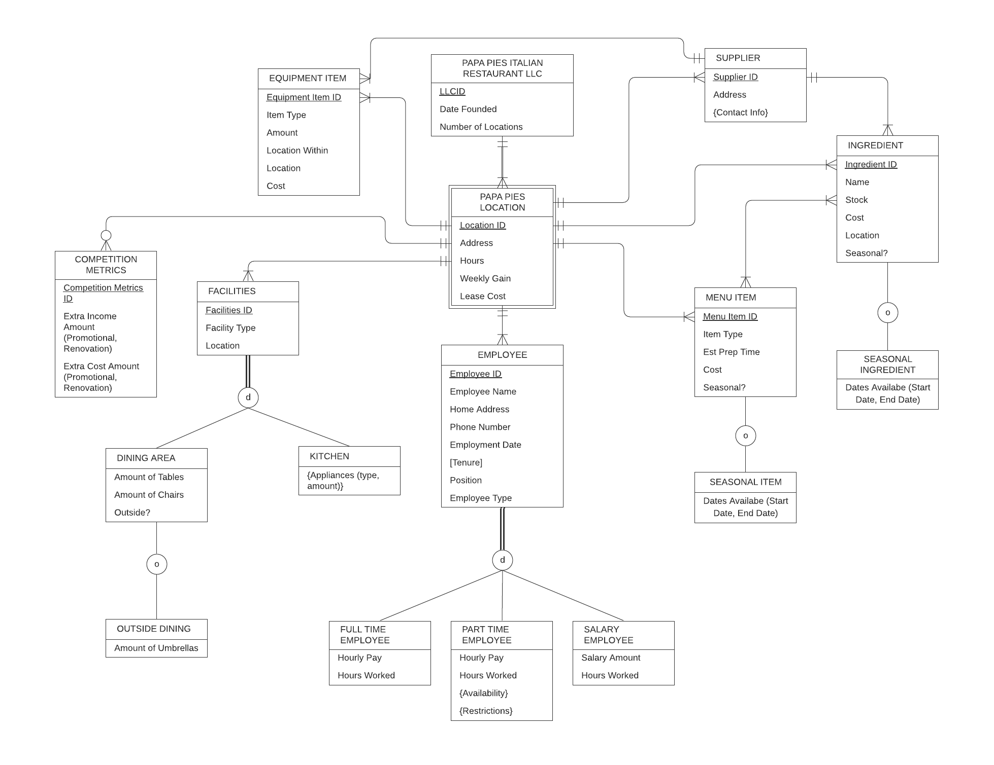

**Papa Pie’s Logical Database Design**

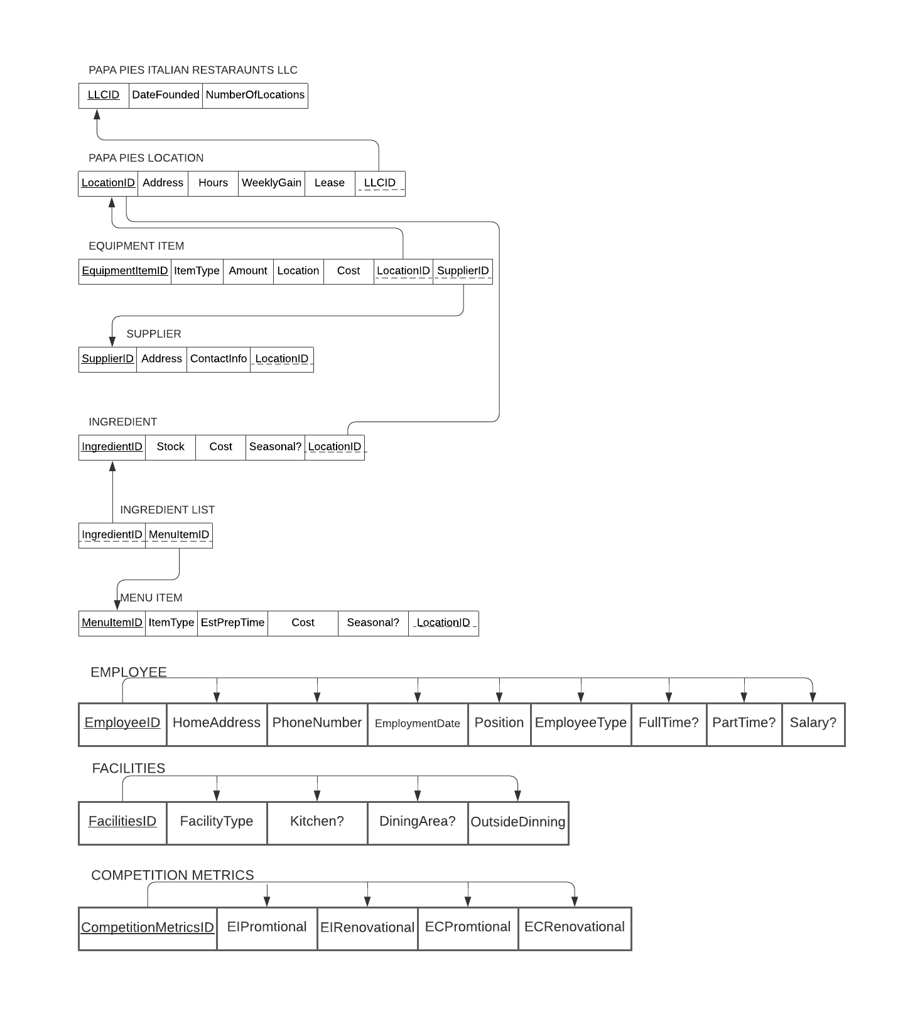

**Papa Pie’s Logical Database Design 3rd Normal Form**

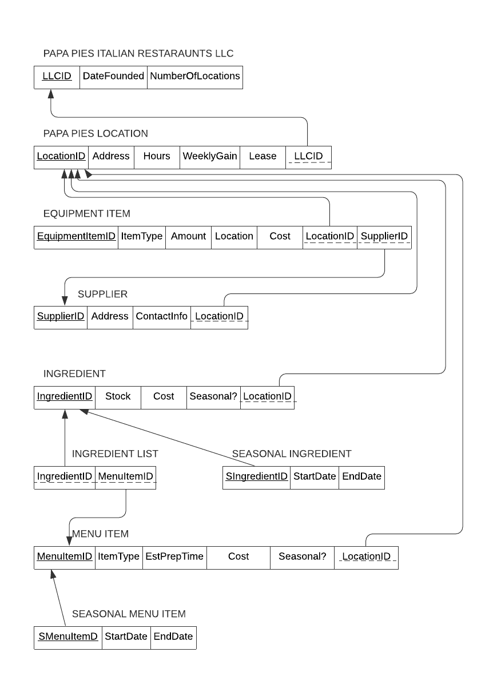

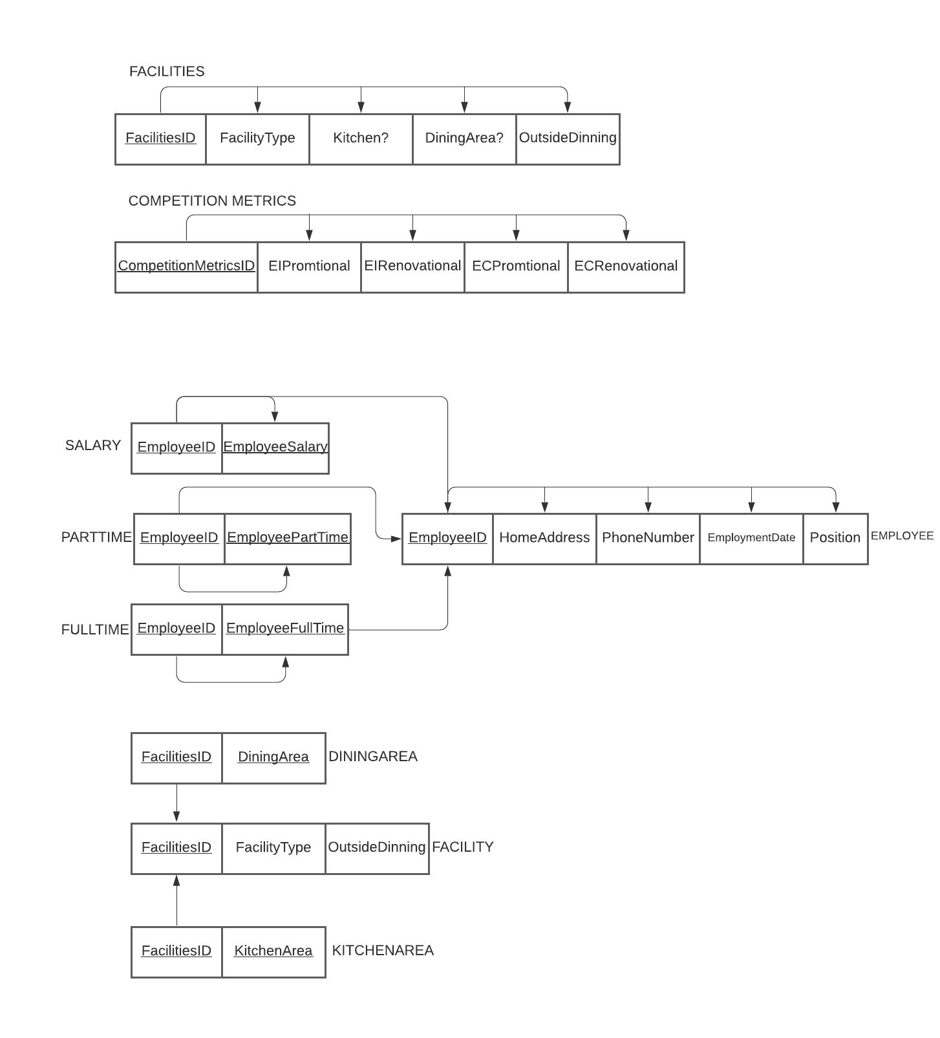

**Database Implementation**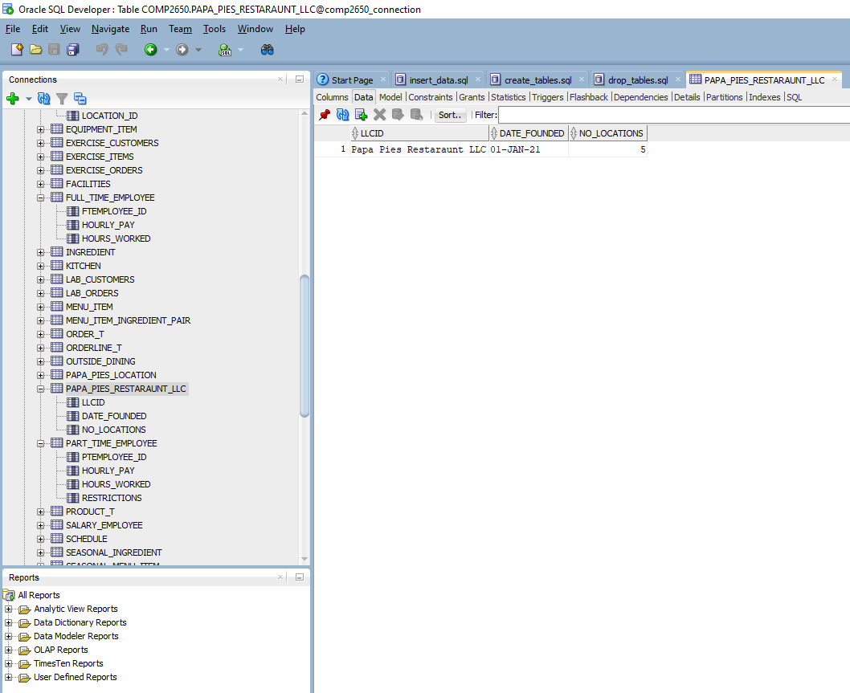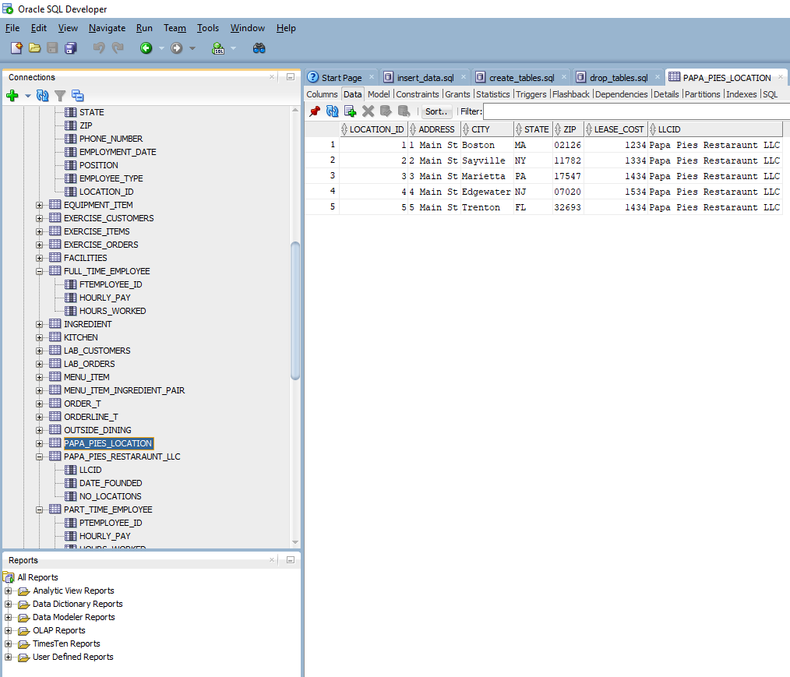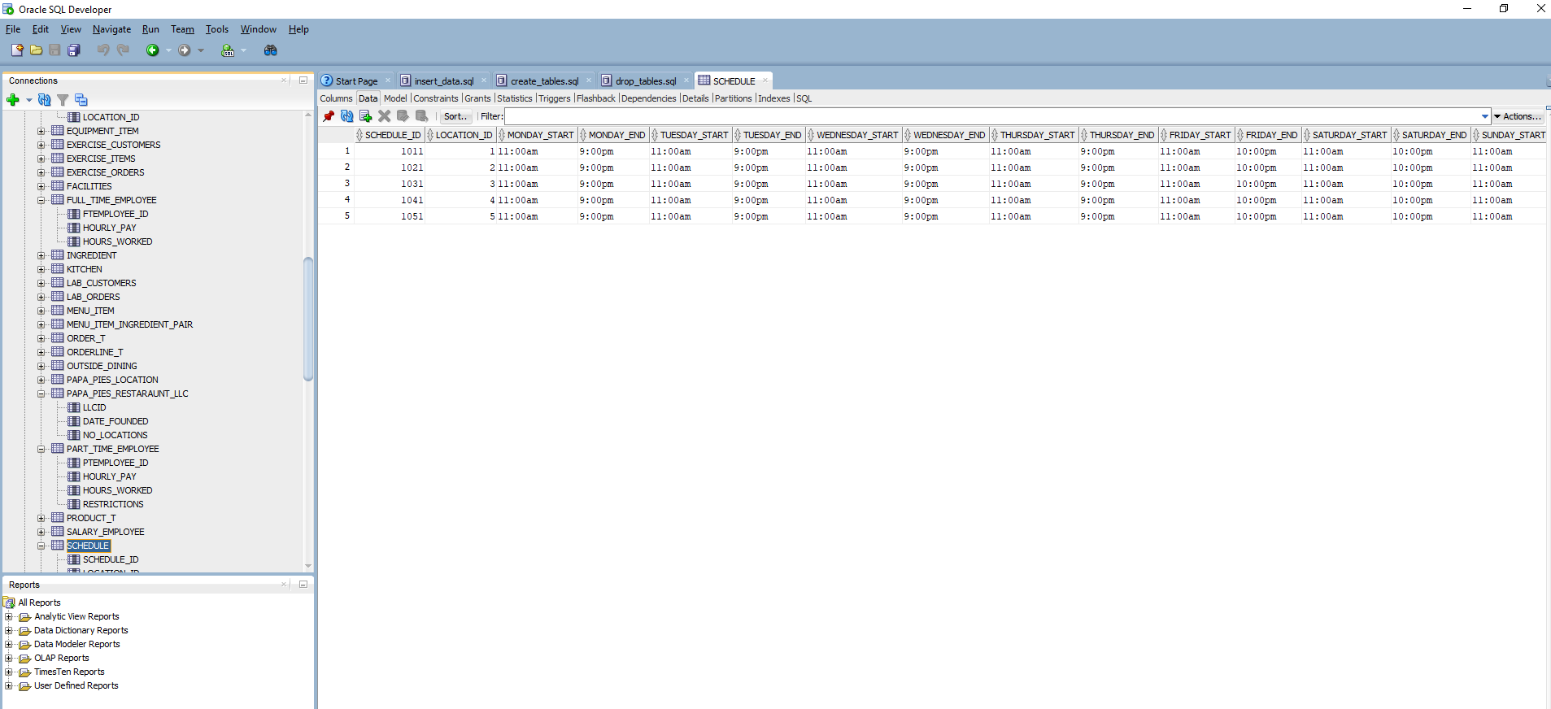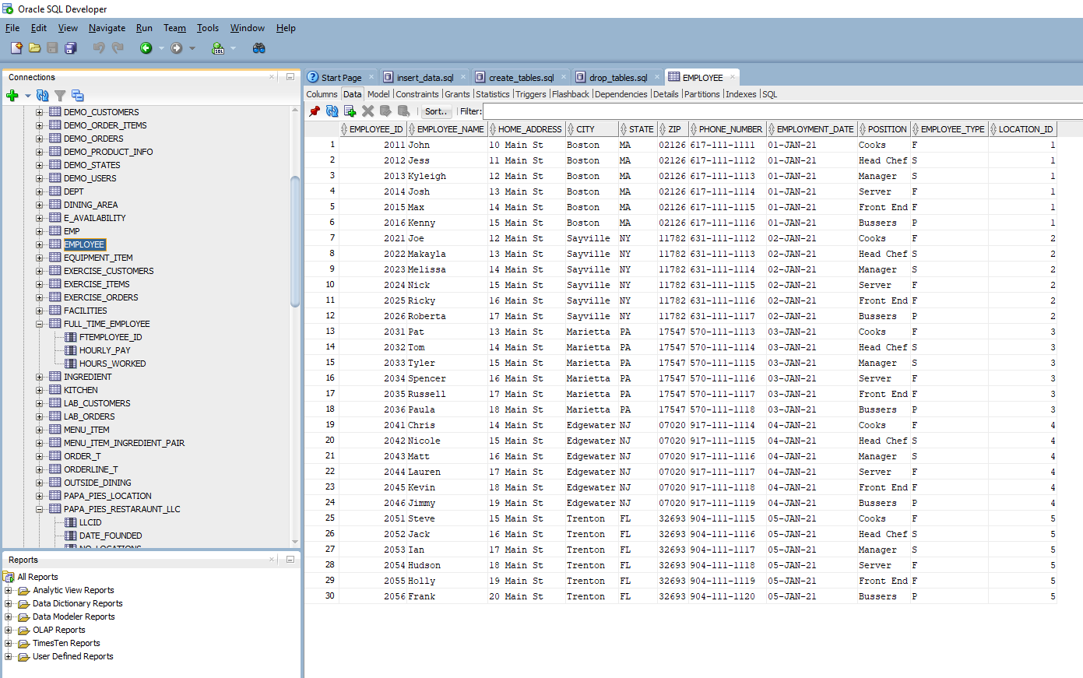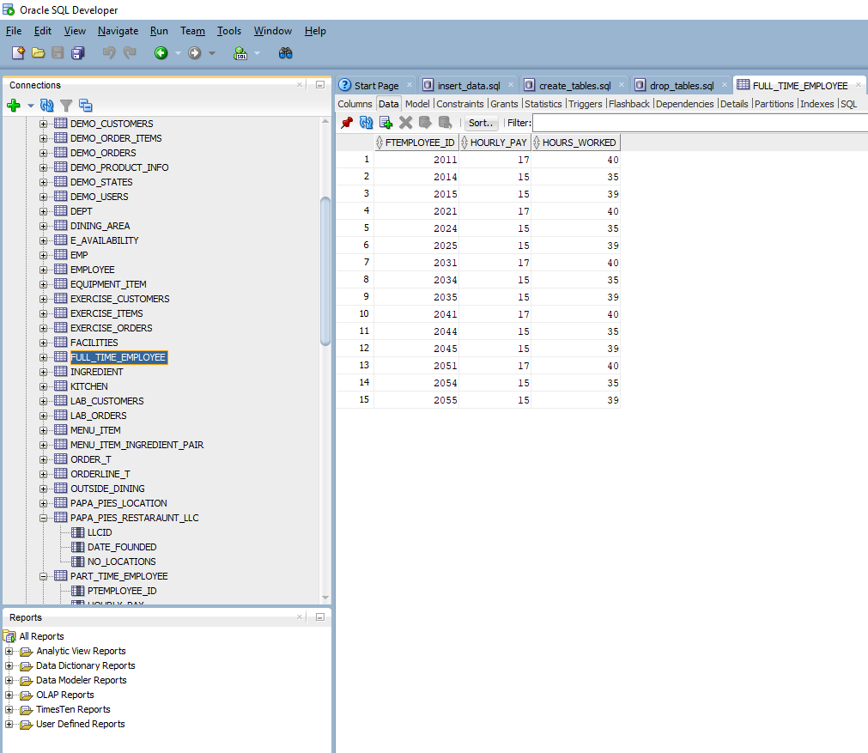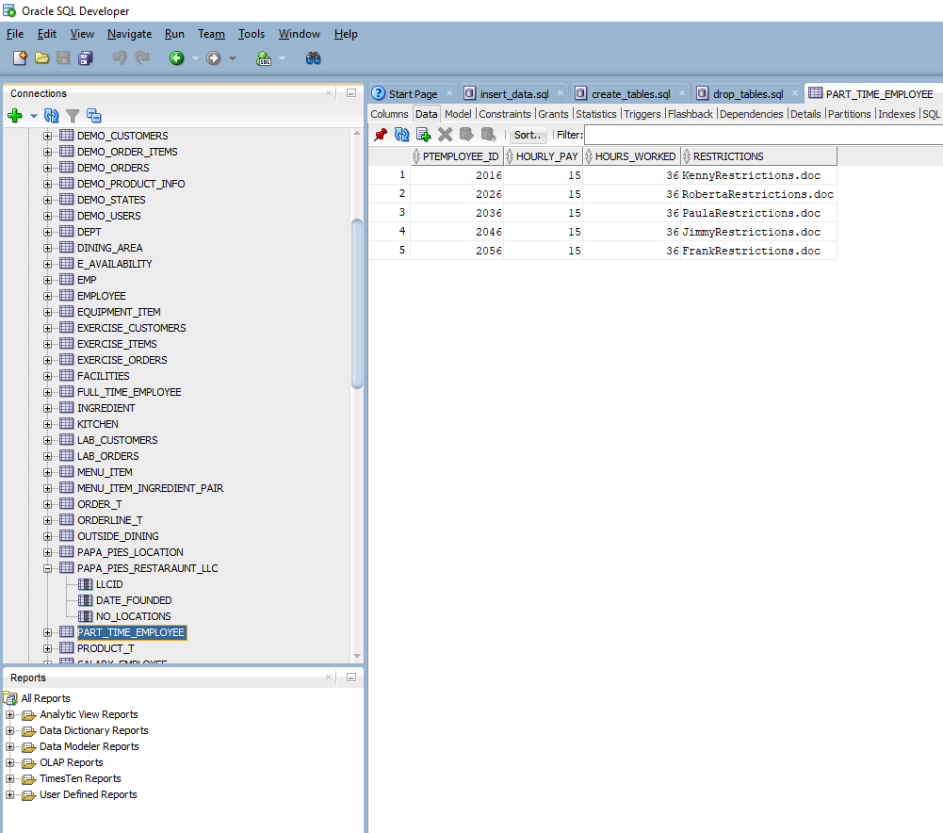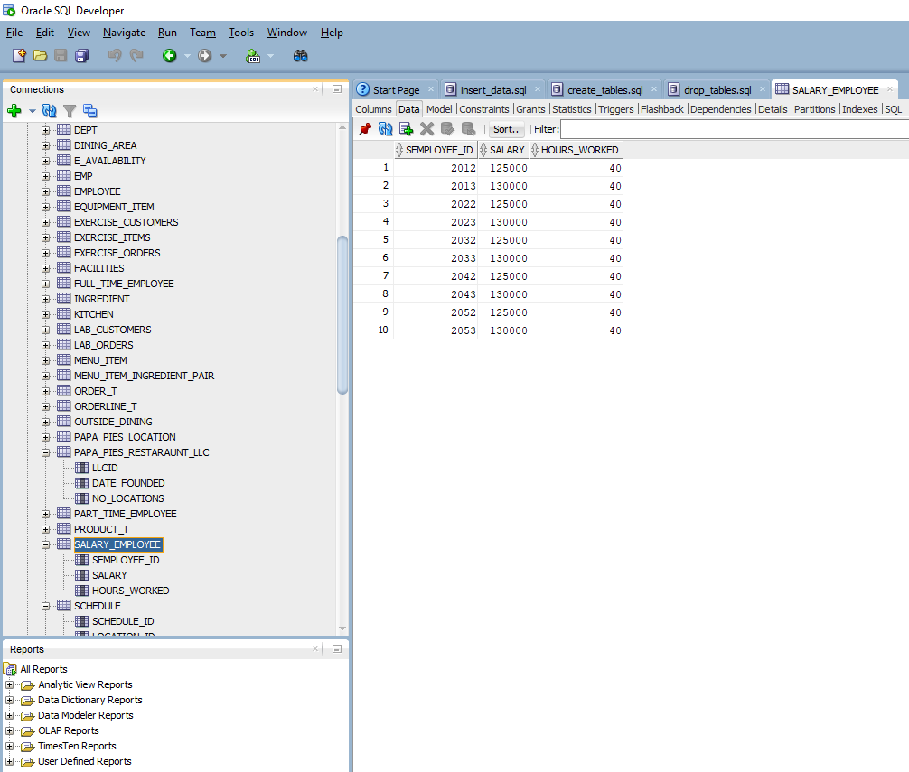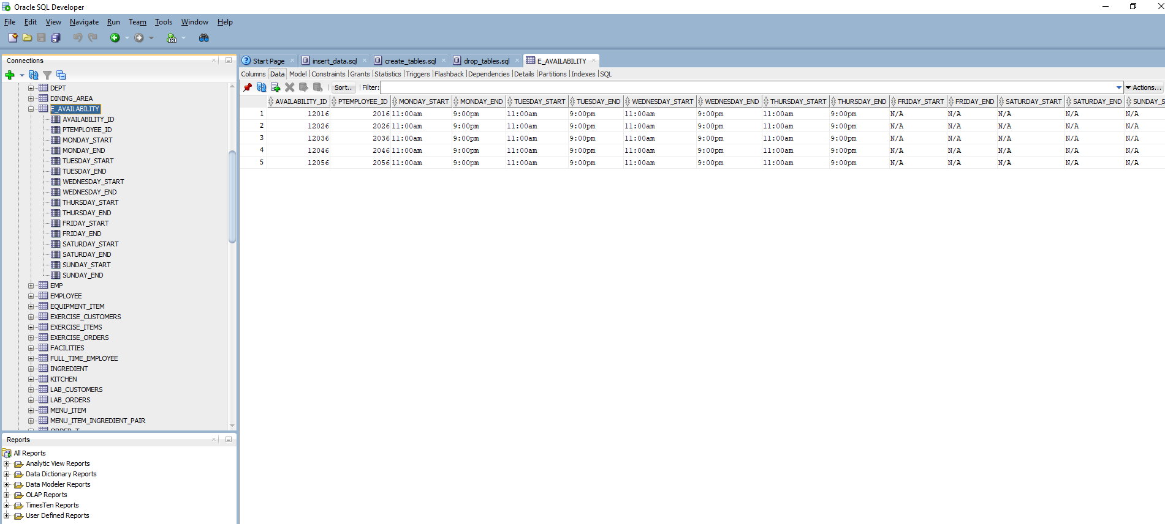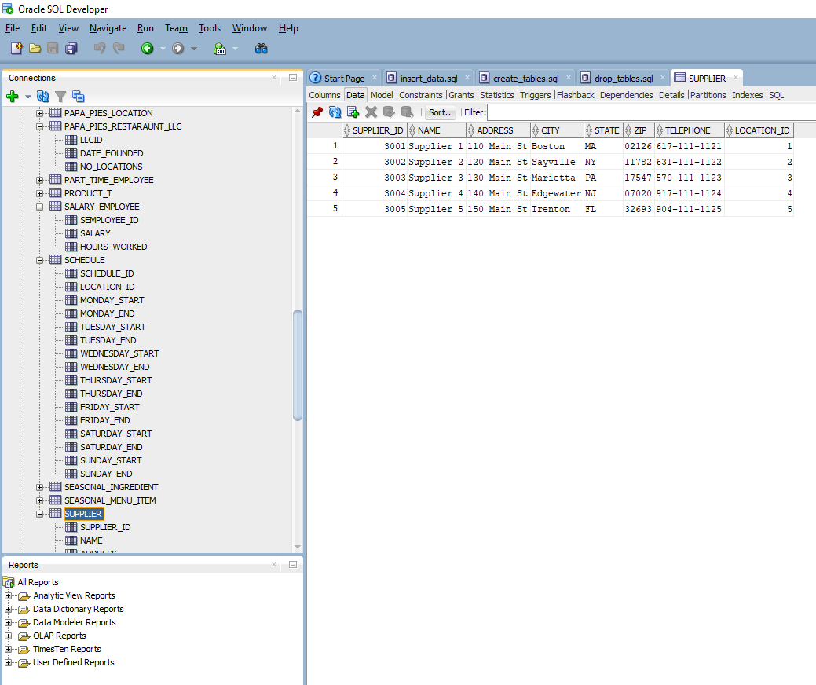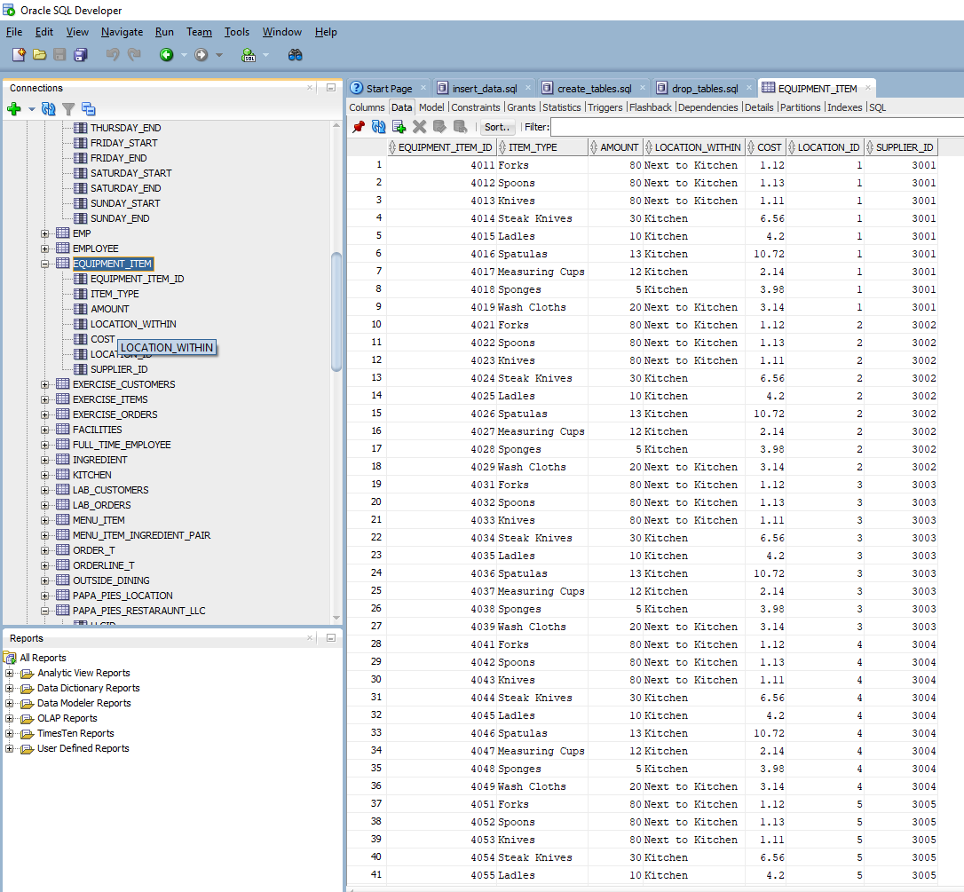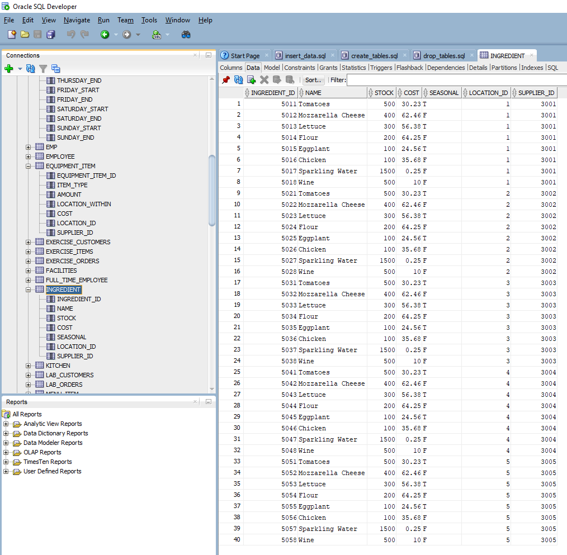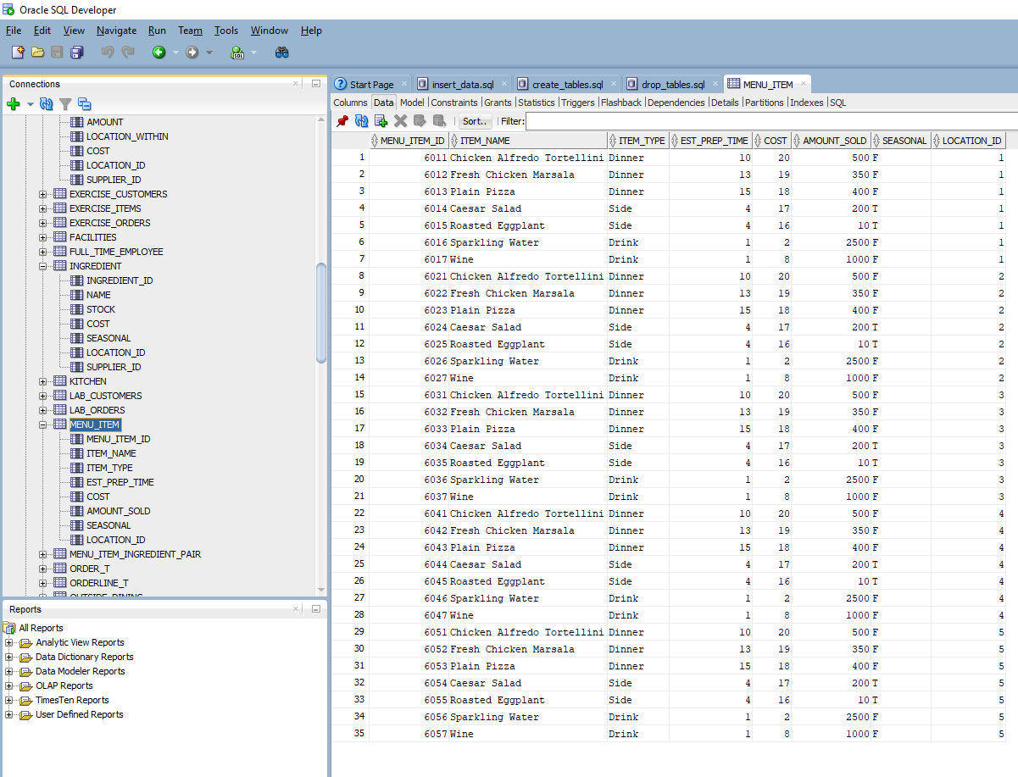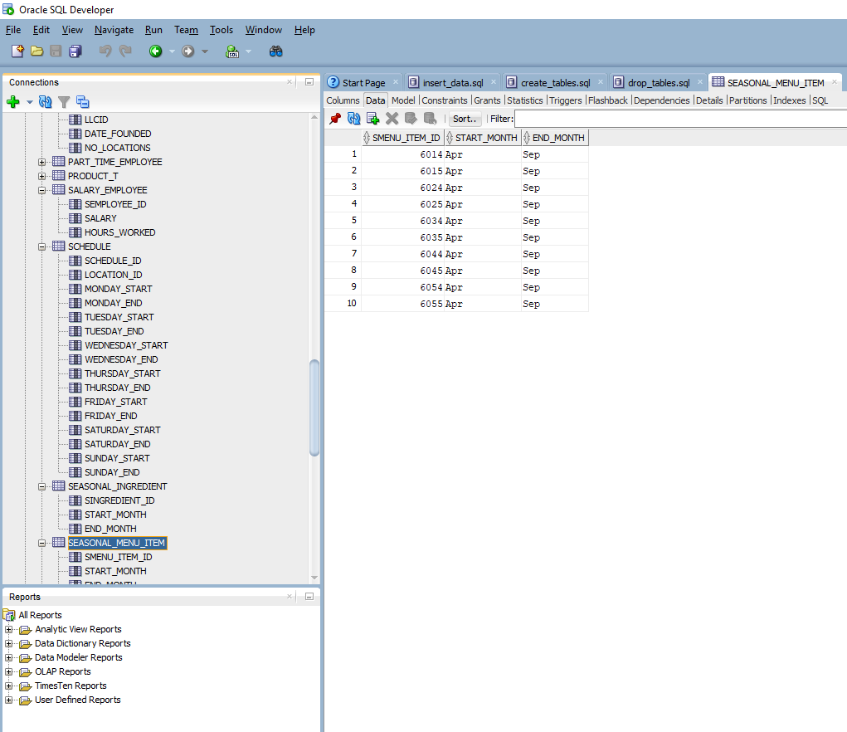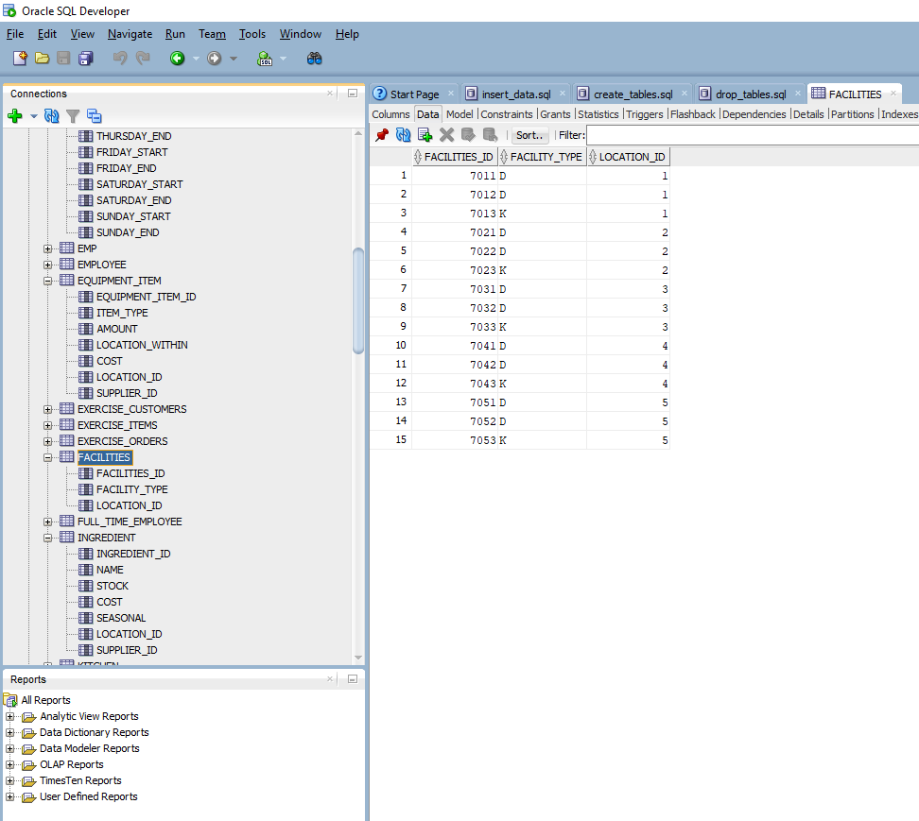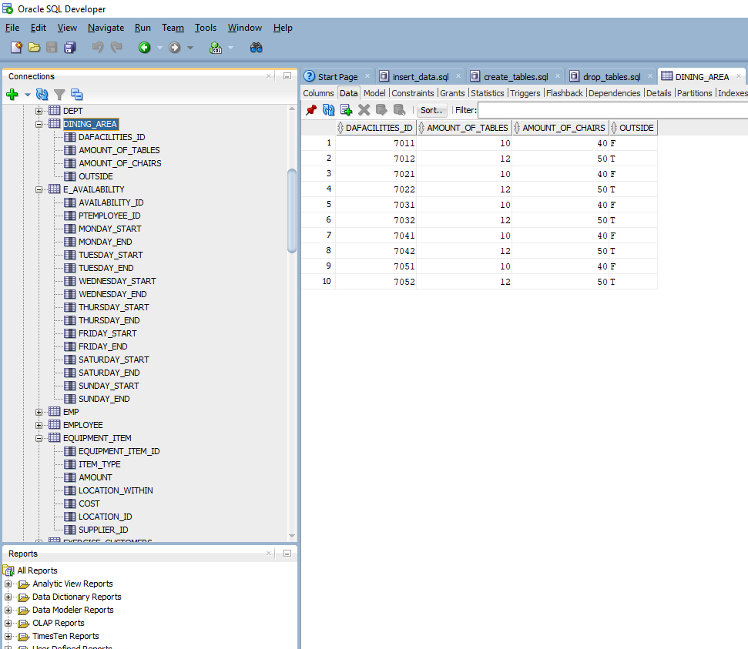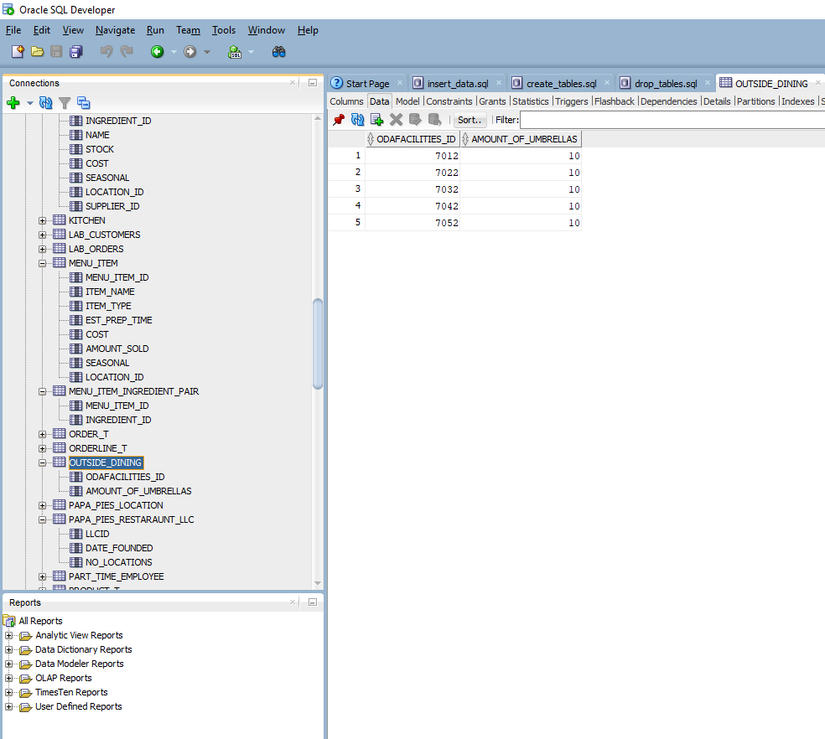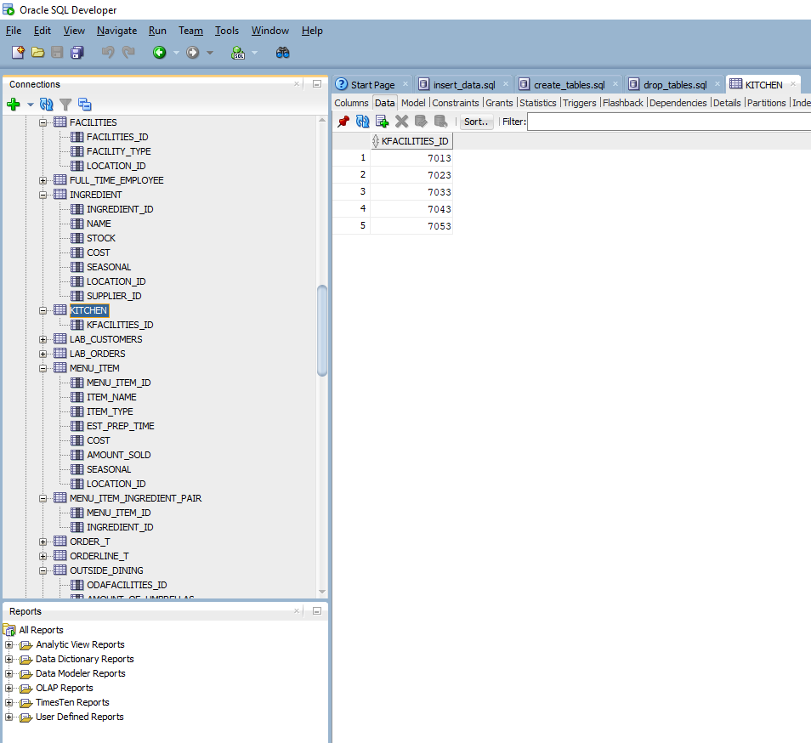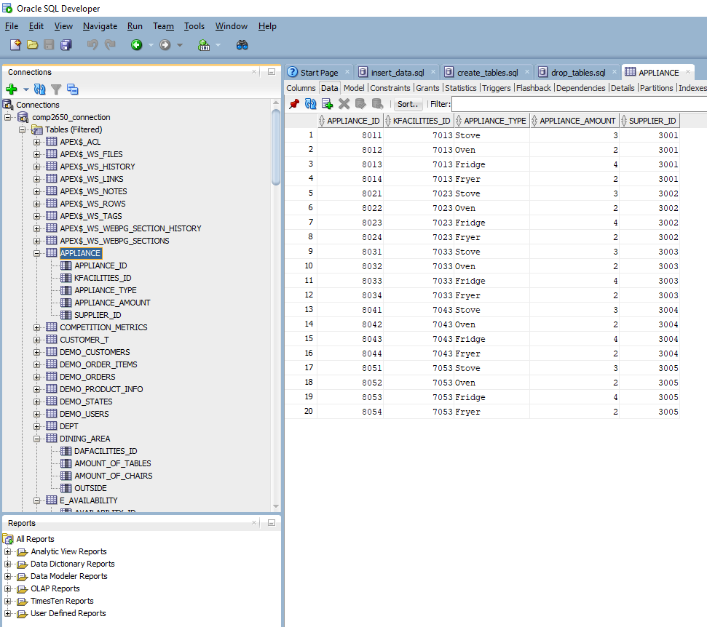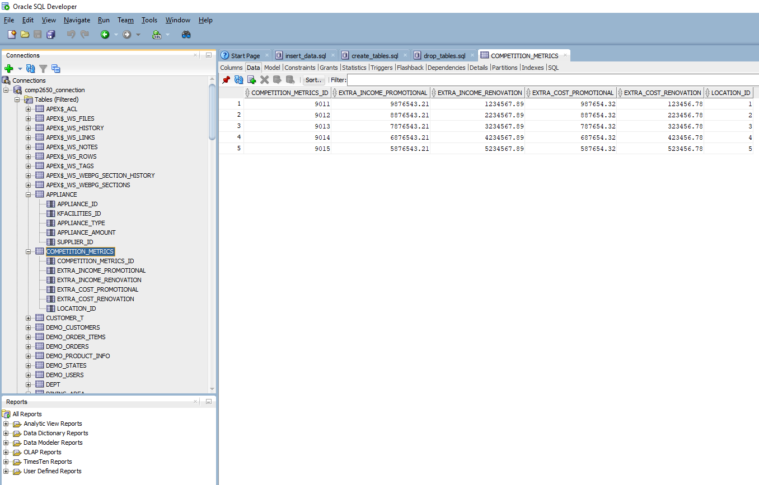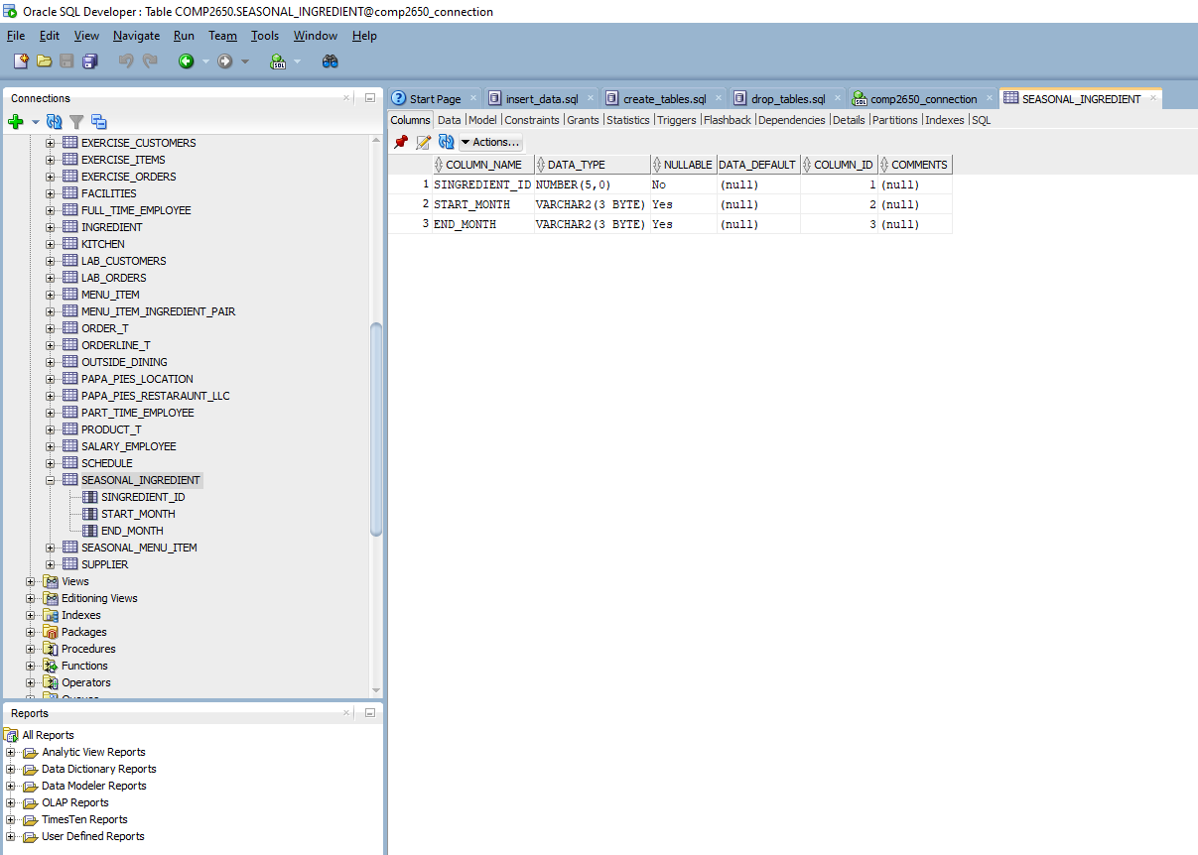

Papa Pie’s Italian Restaurant Report

Wentworth Institute of Technology

Databases COMP2560

Prof. Nguyen Thai

November 27, 2021

Tyler Karpowicz and Richard Walters

**Project Report (State the Problems We’re Trying to Solve)**

As database engineers, we were tasked with creating a database for Papa Pie’s Italian Restaurant LLC. The creation of a database for Papa Pie’s will help the company organize and easily spot flaws, or areas of concern, throughout the business. The database will also be looking at business operations, to see where the company can make changes, improve profits, and lower expenses overall. Furthermore, the database will look at business operations to see where Papa Pie’s can make specific business actions more simplistic, or potentially even automated with ease. Lastly, the database will look at similar competing businesses’ expenses, profits, and overall performance in the area, and how they compare to a given Papa Pie’s location. The database will prove to be most resourceful as a means of aiding the overall success of Papa Pie’s Italian Restaurant LLC.

**Business Statement**

We are database engineers tasked with making a database for Papa Pie’s Italian Restaurant LLC. We create databases such as the one for Papa Pie’s to obtain a more organized look at how business operations are performed. When it comes to creating these databases for businesses, our goal is to find areas of concern in the business. So that the business owners can make changes and improve upon the business overall with efficiency and ease. One example of the areas of concern that will be easily spotted by our database is, taking the costs and amounts of ingredients ordered and comparing them to how many menu items actually sell in a given Papa Pie’s location. Another example of the areas of concern that will be easily spotted by our database is, determining the costs of different equipment and comparing them to which types of equipment is actually utilized in a given Papa Pie’s location. Another example of determining these areas of concern would be, looking at the different pays and skill levels of the different employees throughout the business. The database will also make it easier for the business owner to see the hours each employee generally works in each week, and determine if the employee hours should be increased, decreased, or stay the same. The next example of determining areas of concern though the utilization of the database, would be seeking potential automation of different components in Papa Pie’s Italian Restaurant LLC. This potential automation could lead to greater profit margins and a reduction in expenses for the business overall. Automation could be implemented in food orders, through organizing meals purchased by customers, and comparing them to the ingredients ordered in each food order. The last example for aiding the troubles of the business through the creation and implementation of the database would be, easing the decision-making process of what menu items are good for business and what menu items are bad for business, from looking at the amounts sold of a given menu item in a Papa Pie’s location. As database engineers, through the best of our abilities, we will create a more organized, easy to use format for storing and accessing important company details and components of business, in the name of improving the success of businesses such as Papa Pie’s Italian Restaurant LLC.

**Business Data Model (EERD Diagram)**

We created the business model for Papa Pie’s Italian Restaurant LLC to get a general idea of the structure of the business. We also did this to map out the relationships of different components of the business, and how they relate to each other.



We made Papa Pie’s Italian Restaurant LLC the upward-most component of the data model since the highest level of the business is the LLC itself. The model then leads to the Papa Pies Location, which models the franchised locations of the LLC. These locations then have their own inner-working components, which allows the locations to properly function as a business.

Subcomponents of the Papa Pies Location consist of Equipment Item, Supplier, Ingredient, Menu Item, Employee, Facilities, and Competition Metrics. The Equipment Item entity contains all the information needed for equipment items utilized in the Papa Pie’s Location. The Supplier entity contains all the information needed for the different suppliers for food and equipment for a given Papa Pie’s Location. The Ingredient entity contains all the information needed for different ingredients utilized in the menu items served in a given Papa Pie’s Location. The Ingredient entity also contains the attribute, Seasonal Ingredient which stores the data for ingredients that are, and are not seasonal in the Papa Pie’s Location. The Menu Item entity contains all the information needed for different items on the menu served in each Papa Pie’s Location. The Menu Item entity also contains the attribute, Seasonal Item which stores the data for menu items that are and are not seasonal in the Papa Pie’s Location. The Employee entity contains all the information about the employees that work in the Papa Pie’s Location. The Employee entity also contains the attributes Full Time Employee, Part Time Employee, and Salary Employee, which holds the data for the different types of employees, their pay, as well as their hours in which they work at a given Papa Pie’s Location. The Facilities entity contains all the information needed for the different types of facilities featured at a given Papa Pie’s Location. The Facilities entity also contains the attributes Dining Area and Kitchen, which hold the data for the specifications of each component in the dining area or kitchen in each Papa Pie’s Location. The Competition Metrics entity contains all the information of different similar businesses, the competition, in reference to a given Papa Pie’s Location, as well as their renovation and promotional income and expenses respectively. This business data model will prove to be extremely resourceful for organizing the different components of the Papa Pie’s Italian Restaurant LLC business.

**Database Logical Data Model (3rd Normal Form Relations)**

We created the logical data model for Papa Pie’s Italian Restaurant LLC to get a further clarification and idea of the structure of the business. We also did this to further map out the relationships of different components of the business, and how they relate to each other.





Much like the business data model, we made Papa Pie’s Italian Restaurant LLC the upward-most component of the data model since the highest level of the business is the LLC itself. The model then leads to the Papa Pies Location, which models the franchised locations of the LLC. These locations then have their own inner-working components, which allows the locations to properly function as a business. This model consists of the same, if not similar, subcomponents of the Papa Pies Location. These subcomponents consist of Equipment Item, Supplier, Ingredient, Menu Item, Employee, Facilities, and Competition Metrics. The information within the 3rd Normal Form Relations is very similar, when compared to the EERD’s information contained throughout the data model. This business data model will prove to be extremely resourceful for further organization of different components of the Papa Pie’s Italian Restaurant LLC business.

**Business Data Analysis Charts (Graphs and Tables)**

Through the SQL implementation of the database for Papa Pie’s Italian Restaurant LLC, the business can easily recognize different areas of the business that need greater attention and adjusting, for greater improvement of profits and overall business efficiency and success. One such area of the business we could focus on through the implementation of the database would be, food and drink popularity throughout all the different Papa Pie’s Italian Restaurant locations.

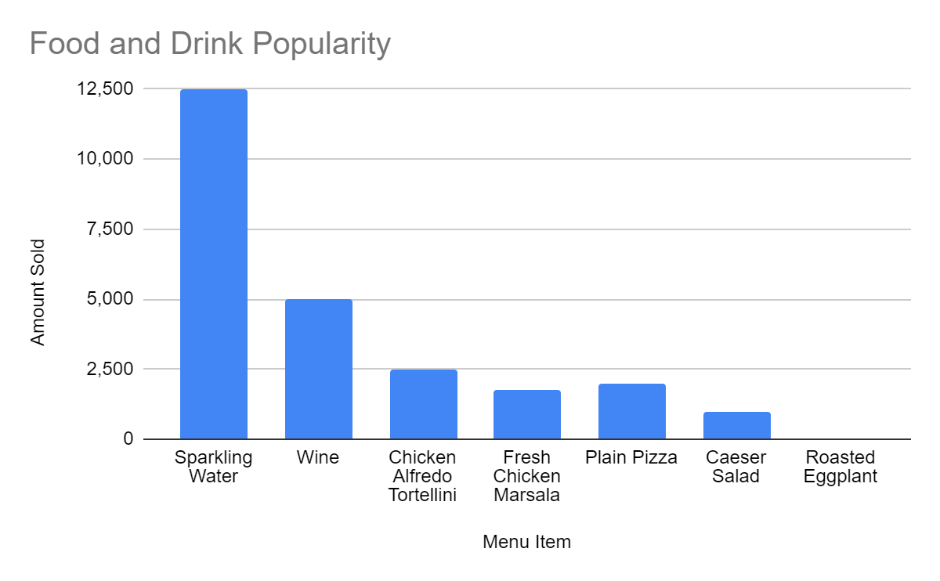

The graph of food and drink popularity throughout Papa Pie’s Italian Restaurant LLC, compiled with the help of information organized by the database, makes various items of food and drink popularity apparent. One such take-away from the graph is, Chicken Tortellini Alfredo is the most popular dish throughout all the different restaurant locations. Another take-away from this graph is, Roasted Eggplant is the least popular dish throughout all the different restaurant locations. Lastly, the graph visualizes that every business location sells a significant amount more drinks than food, with sparkling water being more popular than wine. The graph of food and drink popularity clearly illustrates the correlation between the popularity of drinks, food, as well as the most popular and least popular foods throughout Papa Pie’s Italian Restaurant LLC.

Another such area of the business we could focus on through the implementation of the database would be, employee salary distribution throughout all the different Papa Pie’s Italian Restaurant locations.

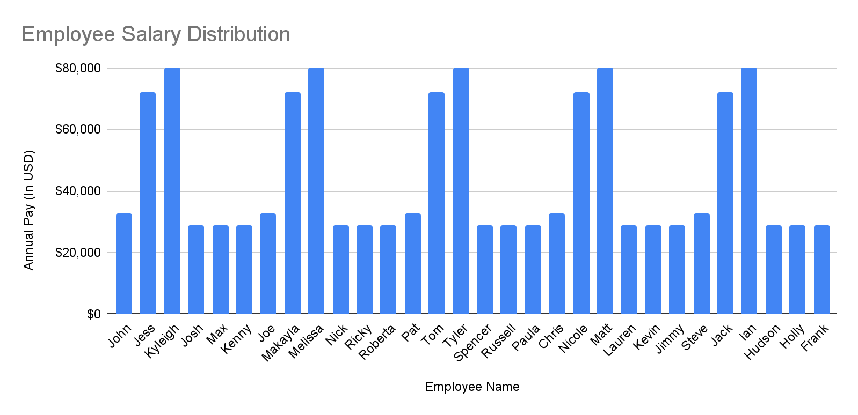

The graph of employee salary distribution throughout Papa Pie’s Italian Restaurant LLC, compiled with the help of information organized by the database, shows the comparison of various employees, accompanied by their yearly salaries. One such take-away from the graph is, about half of the Full-Time Employees make the same amount as the Part-Time Employees, $15 per hour, while the rest make only $2 more an hour, $17 an hour. Another take-away from the graph is, the Managers and Head Chefs have a significantly greater salary, over two times greater, than both the Part-Time and Full-Time Employees. The graph of employee salary distribution illustrates a significant salary difference amongst different types of employees throughout Papa Pie’s Italian Restaurant LLC.

Another such area of the business we could focus on through the implementation of the database would be, sales of meals vs drinks throughout all the different Papa Pie’s Italian Restaurant locations.

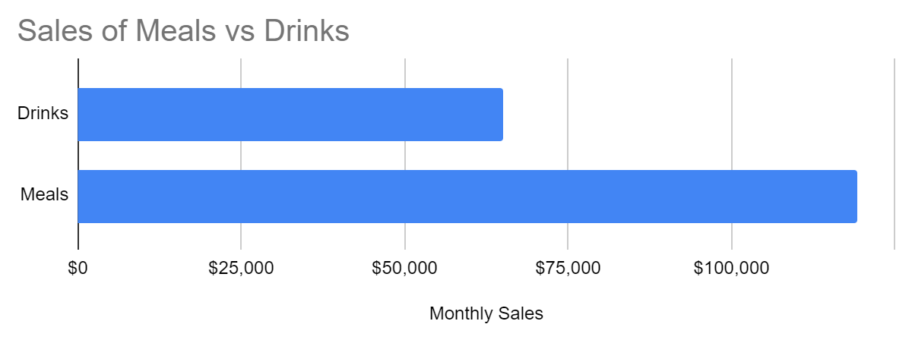

The graph of sales of meals vs drinks throughout Papa Pie’s Italian Restaurant LLC, compiled with the help of information organized by the database, shows various sales metrics of meals compared to drinks. The main take-away from the graph is, the sales of meals are about double the amount of drinks sold on a monthly basis. The graph of sales of meals vs drinks shows a great difference amongst the sales revenue of meals and drinks throughout Papa Pie’s Italian Restaurant LLC.

The next area of the business we could focus on through the implementation of the database would be, the revenue of Papa Pie’s Italian Restaurant LLC vs the competition on a monthly basis.

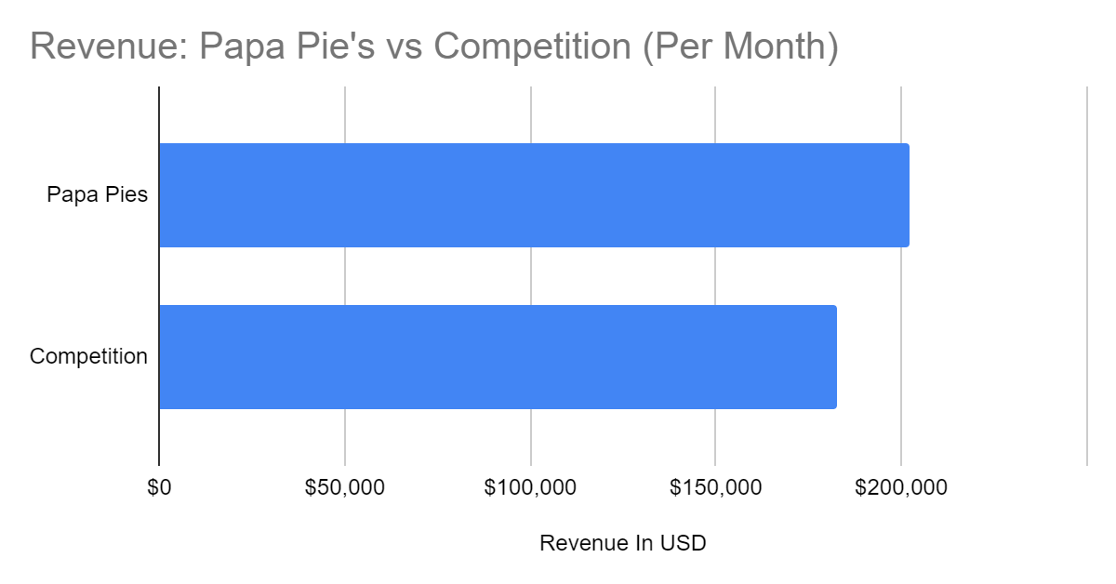

The graph of the revenue of Papa Pie’s Italian Restaurant LLC compared to the competition, compiled with the help of information organized by the database, depicts Papa Pie’s LLC makes about $20,000 more in revenue, per month, when compared to the competition. The competition consists of competing and similar businesses to Papa Pie’s. The graph of Papa Pie’s Italian Restaurant LLC vs the competition on a monthly basis, shows that Papa Pie’s is performing marginally better than the competition.

The last area of the business we could focus on through the implementation of the database would be, a breakdown of the areas of expense on a monthly basis throughout all of the different Papa Pie’s Italian Restaurant locations.

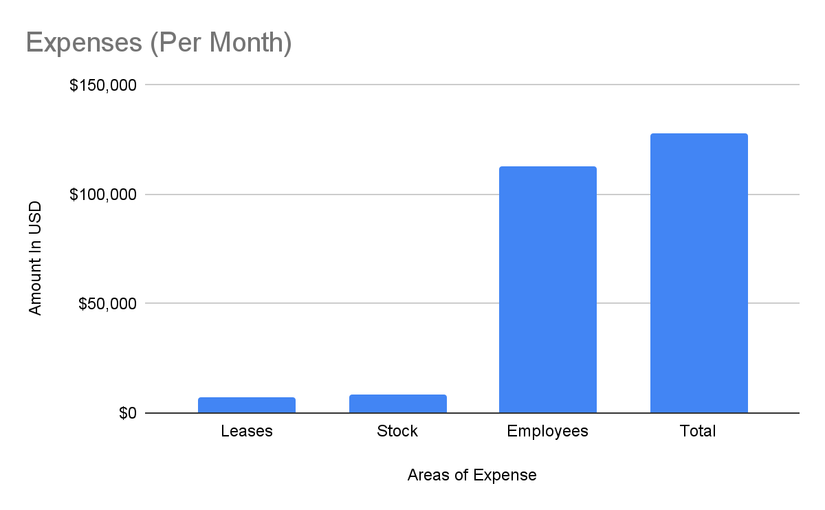

The graph of Papa Pie’s Italian Restaurant LLC monthly expenses, compiled with the help of information organized by the database, depicts that most Papa Pie’s monthly expenses lies within the amount spent on employees. Per month, about $100,000 more is spent on employees compared to inventory and leases. Yet, this still leaves Papa Pie’s with making roughly $70,000 in gross profit each month. The graph of Papa Pie’s Italian Restaurant LLC monthly expenses clearly proves the greatest area of expense throughout all of the locations in the LLC.

**Recommendations for Papa Pie’s Italian Restaurant LLC**

The data compiled throughout the implementation and utilization of the database, enabled us to propose recommendations for certain areas of change that we noticed could be made in Papa Pie’s Italian Restaurant LLC. One such recommendation would be to remove the Roasted Eggplant Appetizer, due to its popularity amongst all the customers throughout all the different Papa Pie’s locations. Another recommendation would be to reduce hours for employees. Due to the high pay of the Head-Chefs and Managers, the massive amounts of hours that they work in each week costs a great amount for the business to maintain. Furthermore, we would recommend Papa Pie’s to have less full-time employees, and more part-time employees, or even reduce the hours of both employees on less busy days to minimize the costs of labor. Additionally, we would recommend that Papa Pie’s reduce the amounts of certain food ingredients that do not sell that well, such as the Caesar Salad, so that the business could further increase its profit margins. As database engineers, we were able to construct a well-organized, easy to use, revealing database for Papa Pie’s Italian Restaurant LLC, our final recommendation is that Papa Pie’s provides us with more time and resources to further the depth, and detail of the database for the restaurant, so the restaurant can further improve, succeed, thrive, and grow as a corporation.